**Summary:** Average to slightly below average pitch framer, struggles especially with pitches low in the zone. Generally strong up in the zone. In prior year was approximately 40 strikes below average on ~4,700 pitches.

**Strengths:** Generally stronger on pitches up in the zone. Does slightly better receiving pitches that are fastballs relative to breaking pitches. Graph below shows location of well framed pitches with links to video below the graph.

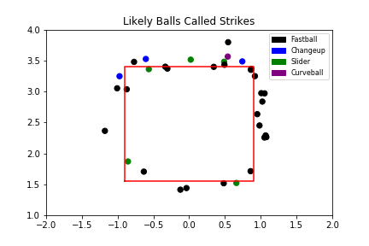

|  |  |  |  |  |  |
| --- | --- | --- | --- | --- | --- |
|  | Fastballs | Fastballs | Sliders | Curveballs | Changeups |
| Links to Video | 0bd5e6f8 | b0c77a7f | b54deba4 | 50c7d27d | df0776ac |
| bc150d17 | e0948c94 | 34ce06b2 |  | 9952cf8a |
| ce97904b | 1f01517e | 25679fcc |  | 4dd8e6b0 |
| 24673f96 | ed7d9e85 | 932f229c |  |  |
| 2b08e982 | 07fbf49a | 9491fe4c |  |  |
| d442b420 | 33abd516 |  |  |  |
| 34908f3d | 1470b279 |  |  |  |
| 8d0b760a | 7bf995c6 |  |  |  |
| f0397451 | ddfaab48 |  |  |  |
| 9c52e479 | 4b08a9af |  |  |  |
| a99e4484 | e7a06d05 |  |  |  |
| 6558039 | b5f0dfa4 |  |  |  |
| 56a59ef6 |  |  |  |  |

**Weaknesses:** Weak on pitches low in the zone. May have a special weakness receiving sliders, as he struggles with a higher percentage of those than any other pitch. Graph below shows location of poorly framed pitches with links to video below the graph.

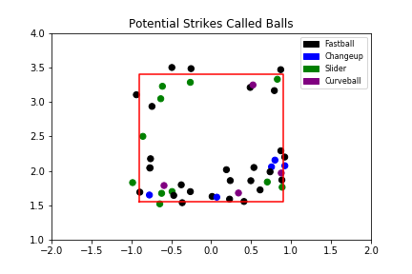

|  |  |  |  |  |  |
| --- | --- | --- | --- | --- | --- |
|  | Fastballs | Fastballs | Sliders | Curveballs | Changeups |
| Links to Video | 5b162628 | ce4893c4 | fe580078 | ad53c278 | 2c34a8c5 |
| a8e0c199 | a3d824dc | c93c4f49 | b7836980 | 77cf66ab |
| 66c25044 | ba38cdd0 | c521b275 | 4d7b445a | 2cfd4687 |
| 4afa71ca | 7f9ee721 | a9b3d0d2 | fd01c073 | 3198e03c |
| e8c7d253 | 475892a0 | aaf40370 |  | 40527691 |
| 4001912f | 9081bf71 | 059f892a |  |  |
| f3a2b90b | daf7497a | 1262b68c |  |  |
| f6b65983 | fbd55187 | def35f63 |  |  |
| b036cb71 | 2aa8a5ce | 4d8ee46f |  |  |
| eb95f157 | 3ed130bf | 847c2543 |  |  |
| 527701c3 | cb1763a6 | 9e53ae41 |  |  |
| 2e246d11 | ef95a71b |  |  |  |
| 572c2268 | fa7e2a2b |  |  |  |
|  | 58dfb60d |  |  |  |  |